https://www.mytipico.com/service-request-forms/
We would need to add 3 new buttons
All forms sent, shall go to officemanagementmalt@tipico.com
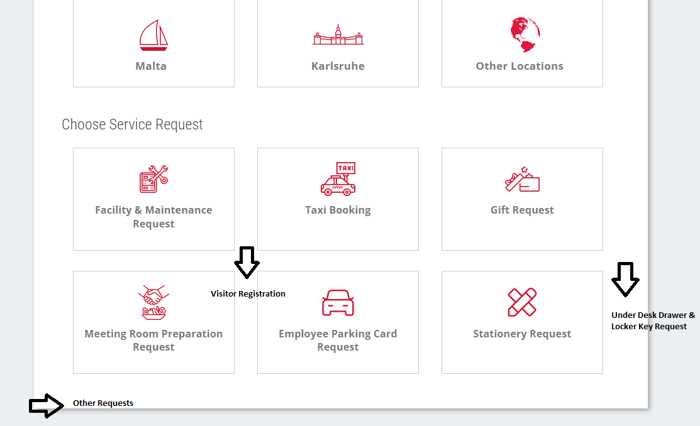
--
New button ‘Other Requests’ can be copy & paste from here https://www.mytipico.com/form-kl-other/?country=KA just make sure the receiving email is the one of Malta
--
New button ‘Under-Desk Drawer & Locker Key Request’ can be copy & paste from here https://www.mytipico.com/form-kl-under-desk-drawer-locker-key-request/?country=KA just make sure the receiving email is the one of Malta
Only small content amendment is the following:
Lockers are located throughout our offices and are handed out on a first come first serve basis.
Employees are encouraged to return their keys to Office Management if they are empty or not in use.
--
New button ‘Visitor Registration’ – picture to be delivered
The employee expecting the visitor is responsible for registering the visitor with security by filling in the form hereunder.
Upon arrival of the visitor, he / she must sign in with security on level 0. Security will then send the visitor to our Office Management Team on Level 1. Office Management will reach out to the assigned contact person who is then responsible for picking the visitor up and accompanying him / her to the meeting room, the same as accompanying the visitor back to the main entrance for check out after the meeting.
Visitors must wear their visitor pass visibly and must be accompanied by a Tipico employee at all times.
Field1 (mandatory) – Name of Visitor
Field2 – Company Name of Visitor
Field3 (mandatory) – Date when access to the Tower is needed
Field4 (mandatory) – Time when access to the Tower is needed
Field5 (mandatory) – Tipico contact person upon arrival
--
https://www.mytipico.com/service-request-forms/
As for the meeting room button, we would like to follow the structure of KA
- Please rename the main button ‘Meeting Room Preparation Request’ to ‘Meeting Room Request’ – please also use the same button as in KA https://www.mytipico.com/service-request-forms/
- Please amend the sub button on the MT side from

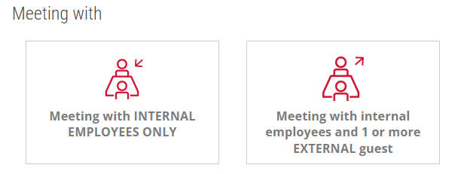
To the following (same as KA side)
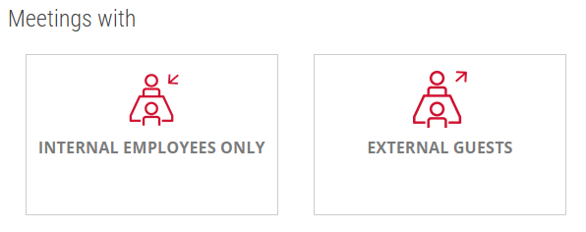
--
Once the user clicks on ‘Internal Employees only’ only 2 sub buttons should appear
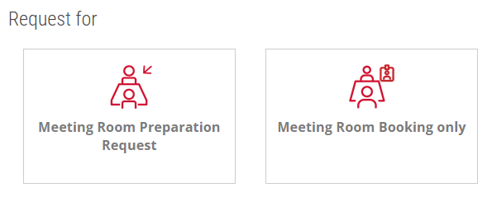
Content for button ‘Meeting Room Booking only’
Please copy & paste content from https://www.mytipico.com/form-kl-room-booking-only-for-meetings-with-internal-employees/?country=KA
The following amendments have to be done
- Intro text
All meeting rooms within the Tipico Tower except the once mentioned in the drop down hereunder, can be booked by every employee via Outlook.
For any other meeting room, Office Management will gladly assist you with the room booking.
- Receiving email address -> Malta
- Drop down meeting room list
  - 7.01. Cristiano Ronaldo
  - 7.02. Buffon
  - Tipico Arena - Level 7
- Remove the field marked
--
Content for button ‘Meeting Room Preparation Request’
Please copy & paste content from https://www.mytipico.com/form-kl-meeting-room-preparation-request-for-meetings-with-internal-employees-only/?country=KA
The following amendments have to be done
- Receiving email address -> Malta
- Drop down meeting room list
- 1.02. Di Stefano
- 6.01. Pelé
- 6.02. Zlatan
- 6.11. Keegan
- 7.01. Cristiano Ronaldo
- 7.02. Buffon
- Tipico Arena - Level 7
- Once the time has been chosen the items the employee can request shall be shown as follows
- Up to 4hrs
  - Flipchart/s (including the pop up to request the number of flipcharts needed)
  - Moderation Kit
- From 4hrs 1min+
  - Flipchart/s (including the pop up to request the number of flipcharts needed)
  - Moderation Kit
  - Fruit (no additional side fields for budget etc. shall open)
  - Biscuits
  - Lunch (the fields hereunder shall show – same as here https://www.mytipico.com/form-internal-meetings-with-internal-employees/?country=Malta

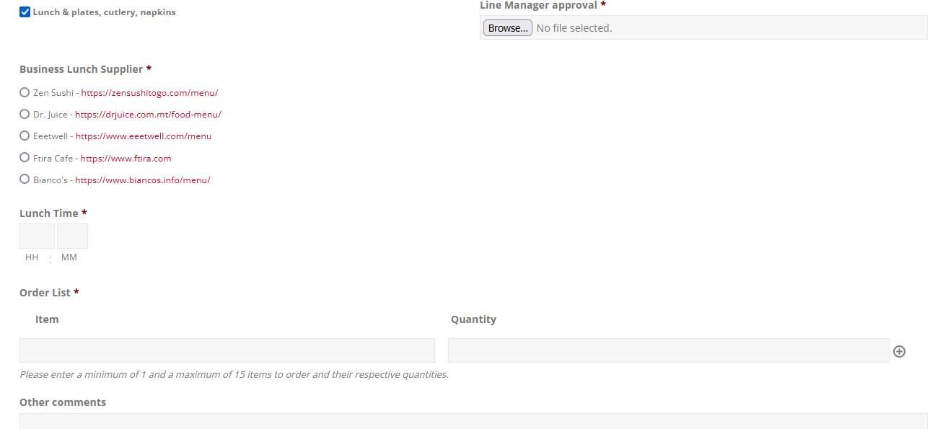
--
Once the user clicks on ‘External Guests’ only 2 sub buttons should appear
Content for button ‘Meeting Room Booking only’
Please copy & paste content from https://www.mytipico.com/form-kl-meeting-room-booking-only-for-meetings-with-external-guests/?country=KA
The following amendments have to be done
- Intro text
All meeting rooms within the Tipico Tower except the once mentioned in the drop down hereunder, can be booked by every employee via Outlook.
For any other meeting room, Office Management will gladly assist you with the room booking.
- Receiving email address -> Malta
- Drop down meeting room list
  - 7.01. Cristiano Ronaldo
  - 7.02. Buffon
  - Tipico Arena - Level 7
Is it possible to amend the marked field so that the requester 1) has to tick the tick box and 2) we guide the requester to the new form ‘Visitor Registration’ without losing the current form? Can you l let me know what is possible?
--
Content for button ‘Meeting Room Preparation Request’
https://www.mytipico.com/form-kl-meeting-room-booking-only-for-meetings-with-external-guests/?country=KA
The following amendments have to be done
- Receiving email address -> Malta
- Drop down meeting room list
- 1.02. Di Stefano
- 6.01. Pelé
- 6.02. Zlatan
- 6.11. Keegan
- 7.01. Cristiano Ronaldo
- 7.02. Buffon
- Tipico Arena - Level 7
- Once the time has been chosen the items the employee can request shall be shown as follows
- Up to 2hrs
  - Flipchart/s (including the pop up to request the number of flipcharts needed)
  - Moderation Kit
  - Tea & coffee station in the meeting room
  - Bottled still & fizzy water
- From 2hrs 1min+ up to 4hrs
  - Flipchart/s (including the pop up to request the number of flipcharts needed)
  - Moderation Kit
  - Tea & coffee station in the meeting room
  - Bottled still & fizzy water
  - Biscuits
- From 4hrs 1min+
  - Flipchart/s (including the pop up to request the number of flipcharts needed)
  - Moderation Kit
  - Tea & coffee station in the meeting room
  - Bottled still & fizzy water
  - Fruit (no additional side fields for budget etc. shall open)
  - Biscuits
  - Lunch (the fields hereunder shall show – same as here https://www.mytipico.com/form-internal-meetings-with-internal-employees/?country=Malta

Is it possible to amend the marked field so that the requester 1) has to tick the tick box and 2) we guide the requester to the new form ‘Visitor Registration’ without losing the current form? Can you l let me know what is possible?
--
It would be also great if once a main button is clicked the other buttons not applicable fade out (like we did for KA)

